**Q1: Which student has the highest and lowest score?**

**Q2: Calculate the range of scores and interpret it.**

**Q3: Is age a strong predictor of score?**

**Q4: What if you remove Fatima’s score from the dataset — how does the mean change?**

**Q5: A histogram shows peak scores in 60–80 range. What does that mean?**

**Q6: What chart would best show score comparison by city and why?**

|  |  |  |  |  |  |
| --- | --- | --- | --- | --- | --- |
| Name | Gender | Age | Score | Preferred Language | City |
| Aamir | Male | 21 | 67 | Python | Delhi |
| Sara | Female | 22 | 82 | Java | Mumbai |
| Zoya | Female | 20 | 45 | SQL | Delhi |
| Mubeen | Male | 23 | 91 | Python | Hyderabad |
| Ali | Male | 24 | 76 | R | Hyderabad |
| Ifrah | Female | 21 | 52 | Python | Mumbai |
| Rehan | Male | 22 | 89 | SQL | Chennai |

**Q1: Which student has the highest and lowest score?**

=MAX(d2:d9)  
=MIN(d2:d9)

**Q2: Calculate the range of scores and interpret it.**

RANGE = MAX(d2:d9)-MIN(D2:D9)

**Q3: Is age a strong predictor of score?**

**Correlation = 0.35  
  
Answer: Weak positive correlation → Not a strong predictor**

NO

**Q4: What if you remove Fatima’s score from the dataset — how does the mean change?**

* If you remove a value **less than the mean**, the mean **increases**.
* If you remove a value **greater than the mean**, the mean **decreases**.
* If you remove a value **equal to the mean**, the mean stays the **same**.

**Q5: A histogram shows peak scores in 60–80 range. What does that mean?**BAR CHART

**Q6: What chart would best show score comparison by city and why?**

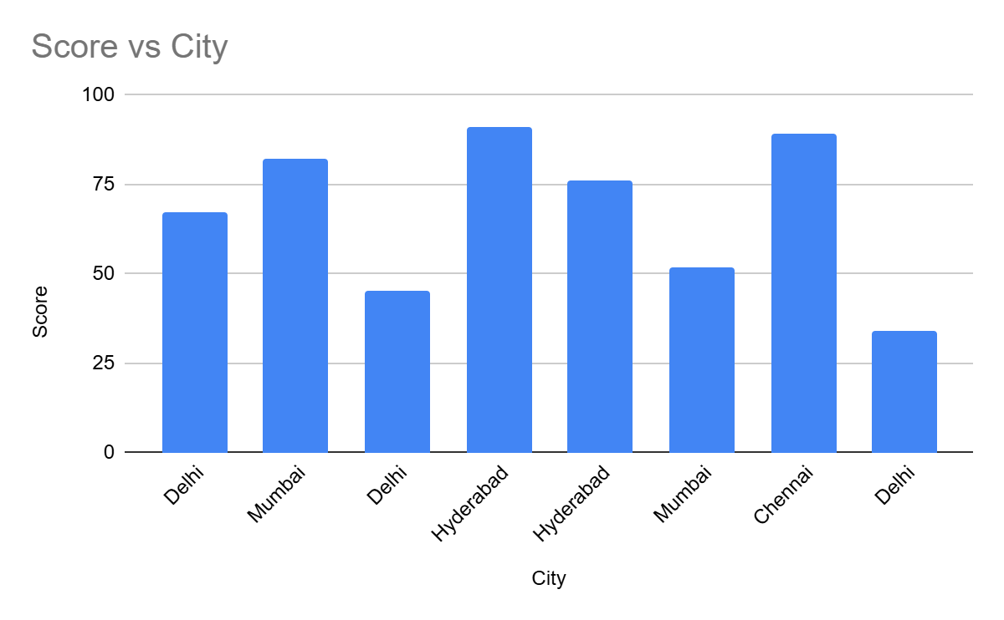

**HomeWork Tasks Solutions - Day 2**

**Q1: Which student has the highest and lowest score?**

**Steps:**

* **Highest: 91 → Mubeen**
* **Lowest: 34 → Fatima  
    
   Answer: Highest = Mubeen, Lowest = Fatima**

**Q2: Calculate the range of scores and interpret it.**

**Steps:**

* **Max - Min = 91 - 34 = 57  
    
   Answer: Score range = 57, showing a wide performance gap**

**Q3: Is age a strong predictor of score?**

**Steps:**

* **Correlation = 0.35  
    
   Answer: Weak positive correlation → Not a strong predictor**

**Q4: What if you remove Fatima’s score from the dataset — how does the mean change?**

**Steps:**

* **New total = 536 - 34 = 502**
* **New mean = 502 ÷ 7 = 71.71  
    
   Answer: Mean increases to 71.71**

**Q5: A histogram shows peak scores in 60–80 range. What does that mean?**

**Steps:**

* **Most students performed in average-to-good range  
    
   Answer: The score distribution is centered around 60–80**

**Q6: What chart would best show score comparison by city and why?**

**Steps:**

* **Use bar chart to compare average scores for each city  
    
   Answer: Bar chart with City on X-axis, Average Score on Y-axis**